**Explaining trip coil current tratest**

**ces through simplified tripping mechanism modelling**

Caveats

There are many key assumptions made given the lack of information regarding the specifics of the mechanisms.

Firstly, it is assumed that a generic magnetomotive device is used to move the plunger. It is the plunger has a constant profile; there is no literature to suggest otherwise.

Secondly, it is assumed that the circuit can be simplified down into a voltage source, circuit resistance, circuit reluctance, and then the dynamics introduced by the actuator’s motion.

Thirdly, the latch mechanism is highly simplified to be modelled as a displacement-dependent dampener, only triggering between a narrow displacement window representing the latch location. Although this is unrealistic, the overall impact this has to the waveform is at a more granular scale, affecting the gradients of the current mainly during the very short “latch time”.

Lastly, most of the internal values are *unknown*. For example, the dimensions of the actuator, the mass of the plunger, the stiffness of the latch, etc. Therefore, it is important to not consider the derived values as the actual parameters of the circuit-breaker, but rather as simply a numerically viable possibility.

Breaking it down

Starting at the most simplified, one can assume an ideal voltage source, a resistor, and an inductor to represent the system. The voltage source is the battery, the resistor is the resistance from the entire circuitry, and the inductor is the trip coil. This is a very simple LR circuit and can still be quite useful.

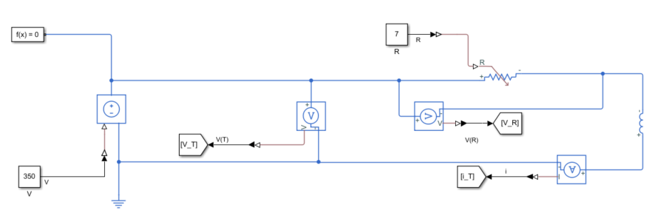

In this simple case, we know that the Resistance (R) and Voltage (V) are 7 Ω and 350 V, respectively. τ is taken as the ratio of L/R, and a very useful heuristic is that 5τ is approximately the time taken for the current to plateau. The plot shows having an Inductance (L) of 1, 2, 3, and 4 with the calculated 5τ for each. As expected, increased inductance increases the time required for the current to plateau, but more importantly, it shows we can use the current to estimate the inductance given that we have the current and the voltage. This is because the resistance can be taken as R = V/I.



Adjusting the voltage affects the max current in a linear fashion whereas adjusting the resistance is multiplicative. Increasing the resistance by 33 %, 50 %, and 100 %, divides the max current by 1.33, 1.5, and 2, respectively. There is also a slowing effect on time taken for current to plateau.





Increasing the voltage at the same rate (%) as the resistance maintains the plateau current and effects only the gradient as like adjusting the inductance parameter directly.

Of course, the actual trip-coil current waveform is significantly different. This is primarily due to the plunger moving through the trip-coil. There is a magnetomotive force induced in the trip-coil that is approximated as the number of winding turns multiplied by the current. As we know the generic shape of the current, we know the MMF waveform will correlate with that. The number of windings is assumed as 1000 for the later models but the effect is explored below. Once the plunger is moving, a voltage is induced that can be approximated as proportional to its velocity opposing the current direction that induced the motion.

Number of winding turns is ranged from 50 to 450 in 50 increments in the plot below.



Another aspect to consider is that the inductance created is also a function of the physical dimensions of the solenoid having a A/l coefficient where A is the cross-sectional area and l is the length of the wire. This is not captured in the generic SimScape model, so instead the length of wire is multiplied by the coefficient instead. For now, the coefficient is kept as 1.

The next model is focussed solely on the voltage induced due to changing magnetic parameters. This is generically approximated as the voltage equal to -N * dφ/dt. Where N is the number of winding turns and φ is the magnetic flux. Therefore, in this closed system, providing a direct MMF source does not affect the voltage induced nor the current levels. Instead, what is more relevant is the magnetic flux and the reluctance.

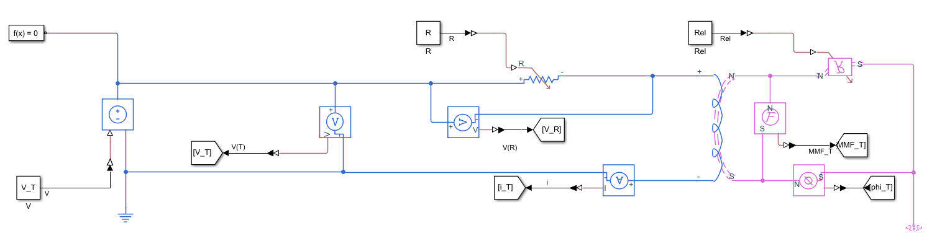

The reluctance in the circuit will be heavily impacted by the plunger location as the magnetic ‘path’ in the trip-coil is through the plunger and the air gap in between it and the buffer. The reluctance of metal is much less than of the air, and so as the proportion of the path filled with air is reduced as the plunger closes the gap, the overall reluctance will fall. As shown in the plot below, decreasing the reluctance increases the rate of current increase, which is the opposite of increasing the inductance which would make sense given their units are inversed.

This means that the rate of current increase initially is expected to be less than if the plunger was already closed. i.e. the gradient at a given current prior the IPk is expected to be less than after it.



Another aspect to consider is having a reluctance in parallel. The Inductance of a solenoid is proportional to both the area and the length and neither are accounted for in the model. A parallel reluctance can account for this. The below plot varied the parallel reluctance between a 0.5 and 5.5 H-1 whereas the plot under that has only a reluctance in series and varies the reluctance by 5000 H-1 without having almost any impact comparatively.





Going to check how reluctance and inductance equate

In addition to the plunger location, the plunger velocity is very impactful as discussed earlier. The figure below shows what happens once the reluctance is decreased on a constate rate down to a fixed value. The rate of decrease is changed between runs. As the rate of decrease is increased, the faster and lower the current drops. Once the minimum reluctance value is reached, the current then increases once more. So, both the gradient and the final minimum current is affected by the rate of reluctance decrease. Here, the reluctance started at 10 H-1and was dropped to 1 H-1. The rate of decrease ranged from 0 to 45 H-1/s. Note how in this extreme example, the initial gradient is larger than the gradient after the reluctance reached its minimum as mentioned earlier to be expected.



The next plot begins the decrease in reluctance before the plateau is reached. This imitates the take-off current required to begin moving the plunger. The parameters have been adjusted but the sweep is kept linearly spaced. Here, we seen the development of the characteristic Ipk and Ibffr. As the rate of decrease is increased, the Ibffr appears sooner and at a lower current. It appears sooner simply because the reluctance reaches its minimum sooner.



The plot below it is the rate of decrease in reluctance along the x-axis against the Ibffr current. Here, increases the rate of change in reluctance is like increasing the velocity of the plunger. The plot below that shows the how much less Ipk is than Iplt against the rate of change in reluctance. The measurements are rough, but it seems like the drop in Ipk is linear to the velocity whereas the Ibffr drop is not. Although this could very much be due to the small values in the Ipk drop. The final plot shows a larger sweep and it does seem to support the notion that the Ipk is much more linearly correlated to velocity than Ibffr.

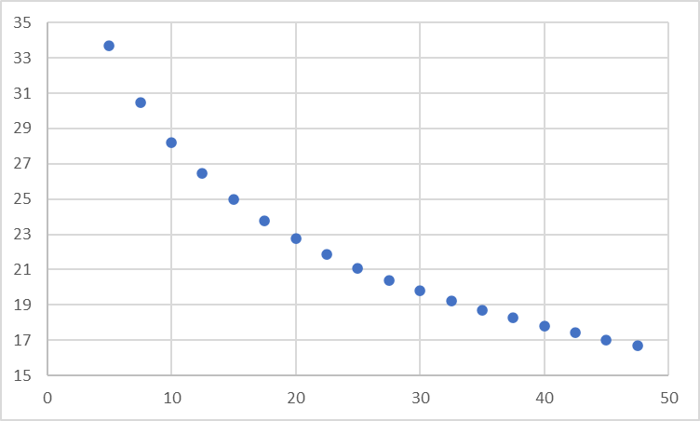

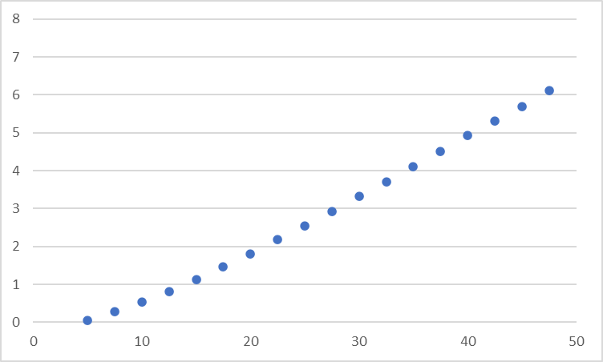

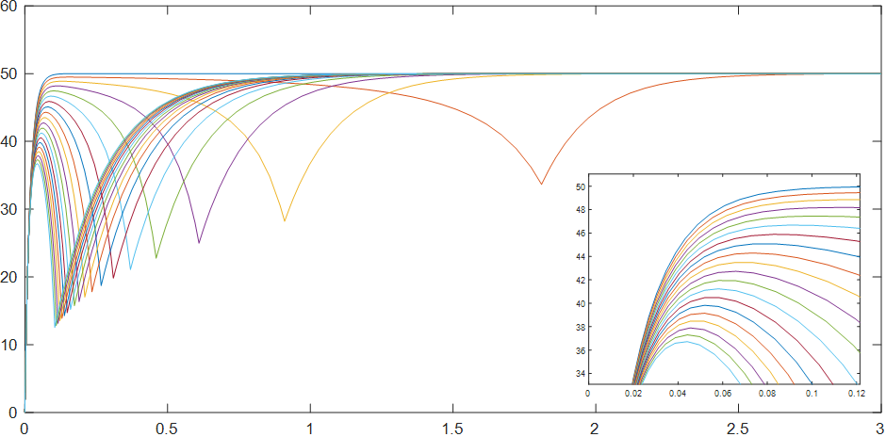

This was assuming constant velocity, which is not realistic. These plots show a range of constant acceleration modelled as a constantly increasing rate of change of rate of change of decreasing reluctance. This has an effect of significantly narrowing the range of results. The Ipks are much closer as their velocities are relatively more similar during the initial periods than with the previous simulations, before diverging at the effect of the acceleration compounds. The plot shows the acceleration coefficient ranging from 0 to 200 and still the range is quite compact. This indicates that the forces within an order of magnitude produce reasonable approximations.



However, this is assuming constant acceleration which itself is still unrealistic. Instead, as the plunger approaches the buffer, the force it feels increases in an approximately squared fashion. This is so until the core begins to saturate where the force then plateaus. ***A very significant simplification is made that the saturation can be ignored***. This would be unacceptable for finer simulations but for the purposes that this model is being used for, it is still functional. The reason for this simplification is that there are no easy estimations to use for this parameter. Also, it has the most affect near the end of the motion, which has the highest velocity, and thus constitutes the shortest span of the model. So, it is hoped that the net effect of the simplification does not have enough time to accumulate into significant deviances in current values. However, it can still cause instability in the simulation.

The model now uses a simplified generic magnetomotive device to translate the magnetic forces into mechanical ones. The reluctance is no longer manually altered, instead it is a function of the plunger’s position and velocity. However, a new set of parameters require for estimation. Additionally, from this point onwards the model settings were changed from variable timestep to a fixed timestep of 0.00001.

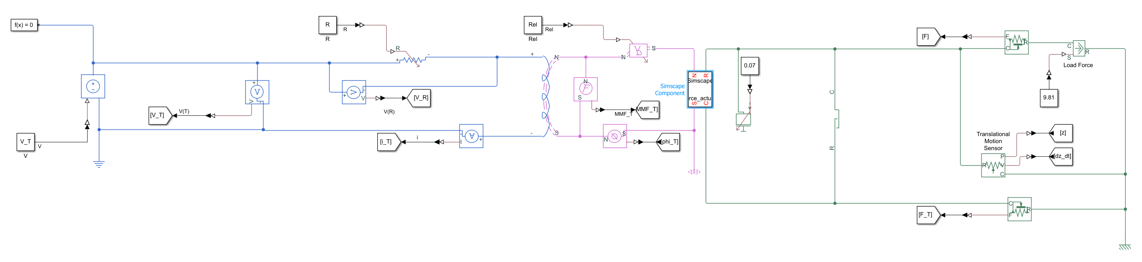

In order to model the physical aspects, the paper [REFERENCE] was referenced for some starting values. A mass of 70 g is used for the plunger, and its cross-sectional area is taken as 1.7671 cm2. The initial air gap as 22 mm, and the buffer location at 2 mm (i.e. a 20 mm stroke). The relative permeability of the material was taken as 1 – **this is hugely conservative**. Furthermore, the overall fixed reluctance due to the circuit is taken as zero, with only the influence of the plunger affecting results. Lastly, a vertical orientation is assumed, with gravity aiding the plunger motion. These are a lot of assumptions piled on at once, so will be looked at individually.

First, the mass is swept from 70 g to 735 g in 35 g intervals. We know that acceleration is proportional to mass and is there connected to the velocity and hence the voltage induced. A lighter plunger will accelerate faster and would induce a greater voltage, all else being equal.



The block being used makes it a bit difficult to do parameter sweeps with some of the other parameters unfortunately. However, we know that both the cross-sectional area and the relative permeability have a similar effect; decreasing them decreases the voltage induced. The MMF = φ x z / (μ0 x μr x A) where μr and A are the relative permeability and cross-sectional area, respectively. The F = -0.5 x φ2 / (μ0 x μr x A) + Losses. Therefore, only a sweep of the μr is done. This is ranging for 0.5 up to 2.4.

As the relative permeability increases, the current levels drop for both Ipk and Ibffr. However, the time for Ibffr seemed non-linear, initially speeding up as relative permeability increased, but then beginning to slow down once again. This is a bit unexpected and is not immediately explainable - **this is a bit of an issue**. 

There is also the aspect of the stroke length, the starting distance, and the minimum air gap. The minimum air gap is usually maintained to prevent the plunger ‘sticking’ post-strike. Also, the plunger is usually also at least partially inside the solenoid at the beginning. i.e. the stroke length is often less than the length of the solenoid. Having a high minimum air gap distance is inefficient. Unfortunately, the model also deviates from reality the furthest when the forces are highest, i.e. near the minimum distance. The plot shows a fixed stroke length of 20mm, starting from 22 up to 30 mm away. As they are moved further away, the Ipk grew almost linearly. The Ibffr grew incrementally less each time. There was also a slight delay in the Ibffr as less force was generated to move the plunger. Interestingly, the smaller the air gap, the slower the rate of current rise after Ibffr. This is because the reluctance will have changed relatively more so. The plot below it shows a fixed distance, but with different reluctance of 2.5 added on each time. The effect looks similar.

This is useful as changing the air gap directly is difficult in the model compared to adding a reluctance.







It is also possible to alter the strike distance. A fixed minimum air gap of 1 mm is used whilst the strike distance is altered instead. As the strike distance is increased the Ipk current rises and the Ibffr current falls and its time is delayed. The greater distance means there is a greater period of time where the velocity is sufficiently high to decrease the current, resulting in a lower Ibffr. However, the greater the distance, the longer it takes for the velocity to reach this threshold, resulting in also a higher Ipk.



The effect of gravity is minimal as shown in the plot below. Please note that as other forces are added, then its effect maybe greater. As the forces are more balanced, the more relative significant this force will have. Just for reference, increased levels of G were looked at. It looks very similar to the effect of pretension in the spring as shown later.

 

The reset mechanism for these solenoids are usually springs, these will oppose the motion towards the buffer. Ideally, they would minimally affect the closing speed, whilst still being stiff enough to ensure the plunger does not get stuck onto the buffer once deenergised. There are two parameters two an ideal spring, its stiffness, and its pretension.

Below is a plot of increased spring stiffness starting from 1 N/mm up to 46 N/mm. It shows that its impact is not too significant until the stiffness exceeds a threshold upon which the Ibffr time begins to slow and its current increase. It seems unlikely springs of such stiffness would be used.



The other aspect that can be altered is the pretension on the spring. Using a stiffness of 5 N/mm, a range from 1 mm to 46 mm was looked at and show below. Although note that the pretension’s affect is very much tied to the spring stiffness. However, what we see is a much greater impact on the Ipk in both time and current, and the impact to Ibffr current is pretty much gone. The impact to Ibffr time is still present. It would appear inefficient to use pretension rather than a stiffer spring as you would only desire its force to detach the plunger from the buffer, after that point not much force is needed. Pre-tension is used when a higher initial force is needed at lower levels of displacement.



For now, the spring is once more removed, and friction is looked at instead. This is slightly more complicated as there are several parameters and I am not totally sure I understand them. This the diagram from Matlab.

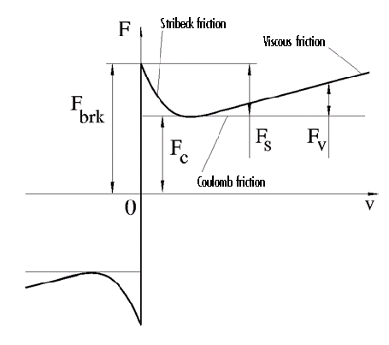

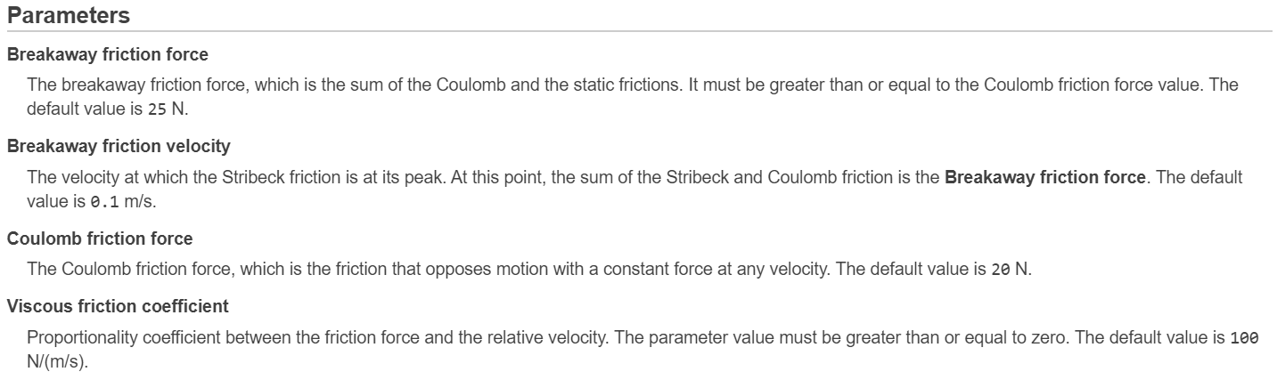

The equations used by Matlab are the following:

*F*=√2*e*(*Fbrk*−*FC*) ⋅ exp(−(v/v*St*)2) ⋅ v/v*St*+*FC*⋅tanh(v/v*Coul*) + *fv*

*vSt*=*vbrk*√2

*vCoul*=*vbrk*/10

*v*=*vR*−*vC*

One aspect is the viscous coefficient, which is the friction than linearly scales with velocity. This is the *fv*. Next is the coulomb friction, which is the minimum friction at any positive velocity. It is the constant that the Stribeck and viscous frictions are superimposed onto. The Stribeck friction is a decaying function peaking at very low velocities. The sum of the Stribeck friction and coulomb friction at near-zero velocities is the breakaway friction and is the force required to overcome the static friction. Last, you have the breakaway velocity which I assume to be the point you switch from static friction to the viscous friction. **I am not sure if I understood the breakaway force and velocity correctly**. Regardless, we can look at the impact of the parameters. The following plots are first looking at the forces. A linearly increasing force is applied and a break away force of 2 N is used. The other parameters are set to 0.00001. There are no other components except the mass and hard stop in this model (i.e. no inductor, no voltage, etc.). We see the force rise linearly until the limit of 2 N is reached, during this, there is no motion. Once the limit is reached, motion begins, and the force drops to 0 until the maximum displacement is reached and other mechanisms kick in. This happens at exactly 0.05 seconds. Changing the breakaway force changes the breakpoint where the displacement begins as expected.

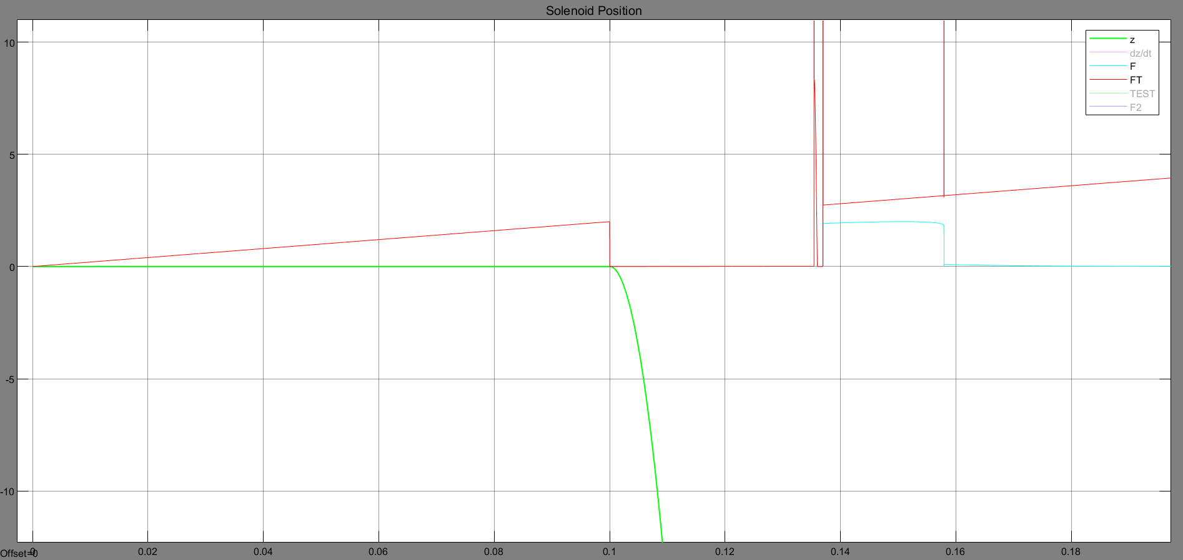

Having the breakaway force set at 1 N and changing the breakaway velocity to 1 mm/s we see that the displacement begins immediately, however at a much lower rate, furthermore, the drop-off in force now has a slightly rounded edge and is delayed. The displacement is accelerating throughout. The velocity reaches approximately 1 mm/s before the force drops off sharply. When the breakaway velocity is adjusted to 2 mm/s the force drops off sharply again at approximately 2 mm/s. It is not immediately apparent how it calculates the amount of force to allow through to allow the acceleration.

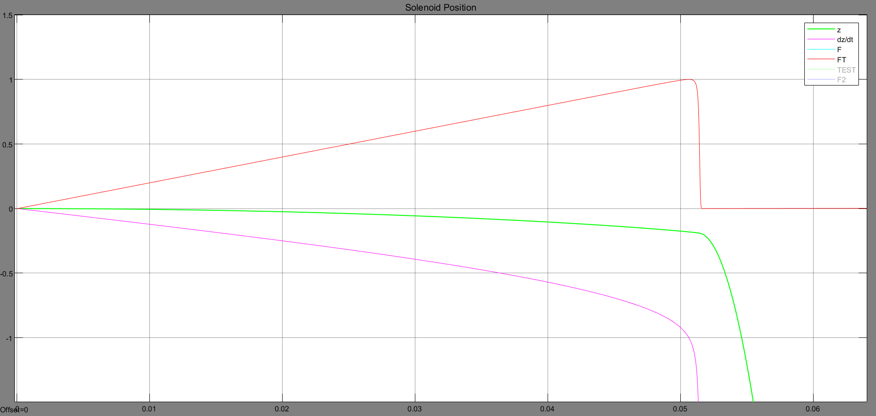

The breakaway velocity is returned to 0.00001 mm/s and instead the coulomb friction is increased to 0.5. The plot shows once the force threshold is reached, the residual force thereafter is equal to the coulomb friction. Adjusting the value behaves as excepted. Adjusting the breakaway velocity here does not have any new effect beyond what was discussed above.

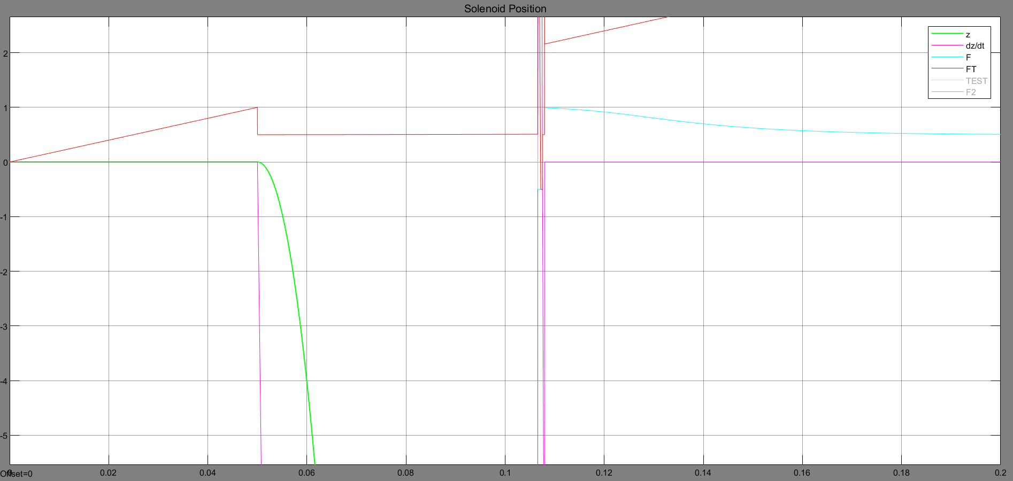

Lastly, adjusting the viscous coefficient to 0.001 whilst reducing the coulomb friction once more is shown below. It shows the force dropping down to the coulomb friction and this increasing seemingly linearly with the velocity.

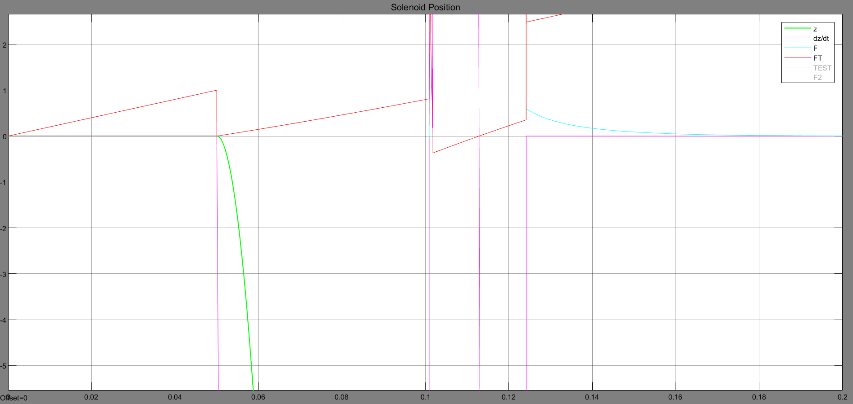

However, if the value is increased to 0.01, we instead see a nonlinear response. The velocity increase is also not linear at this point. Increasing it higher still to 0.05 we see that it is actually saturating at the level of the original force being applied.

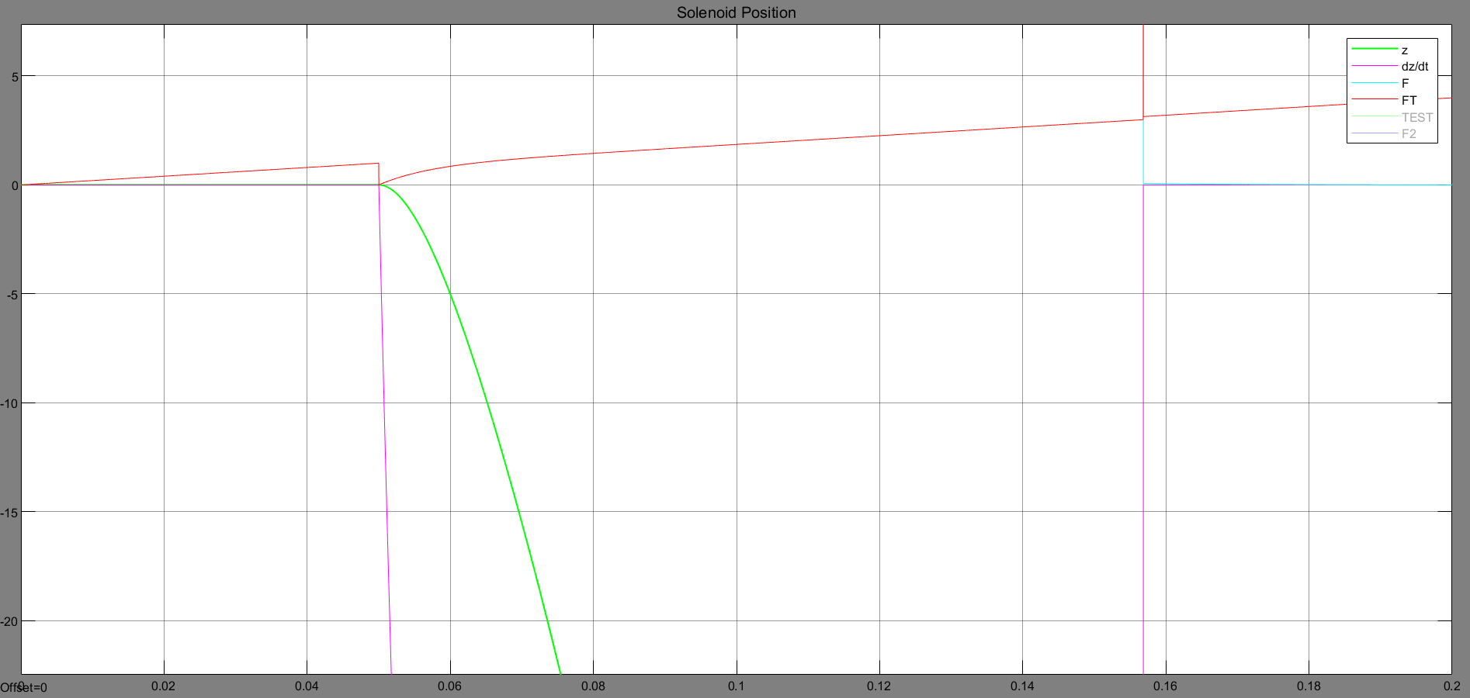

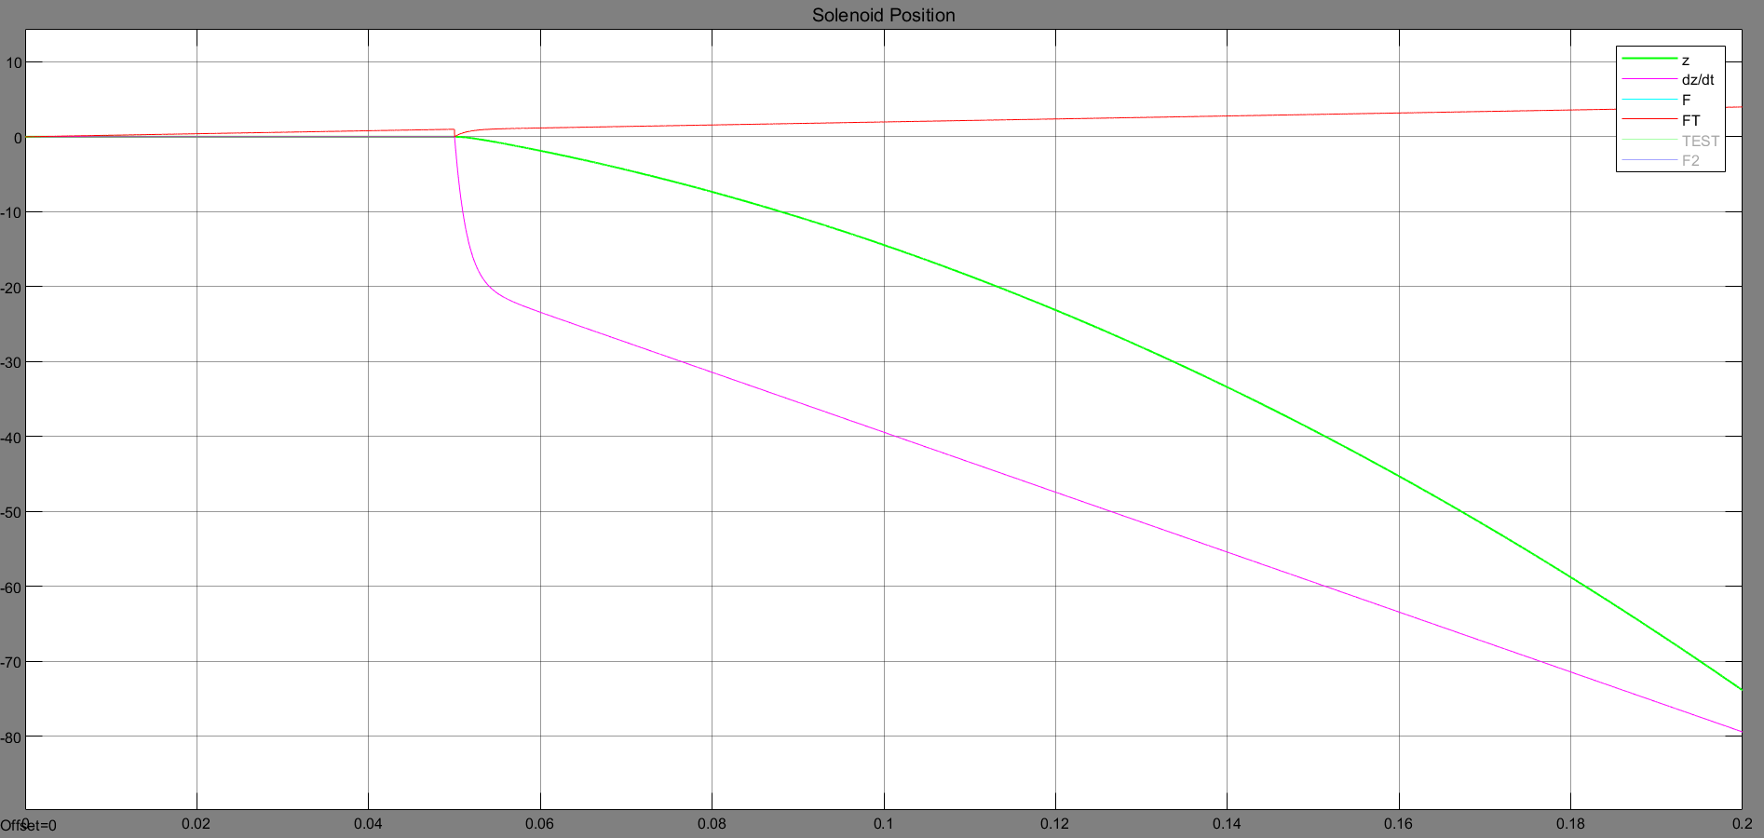

Adding the coulomb friction adds a minimum value to the friction once the threshold is reached.

It is the breakaway velocity that is the hardest to understand and does not seem to be strictly needed. Therefore, it will be kept at near zero whilst the other parameters are used instead.

Having looked at the impact of the friction parameter in the simplified model, we can return and apply them to the usual model. The shapes of the curves look similar with mainly the starting point of the decline in current changing. Furthermore, the Ipk gets delayed non-linearly. It is worth noting that having a high breakaway force and a low coulomb friction should mimic ‘stiction’. Therefore, the plots indicate stiction does *not* look like what we had assumed before; a lump during the saturation curve prior to Ipk. In hindsight this makes sense as stiction does not cause strange jumps in the velocity, but simply a higher acceleration once the breakaway friction is finally met.

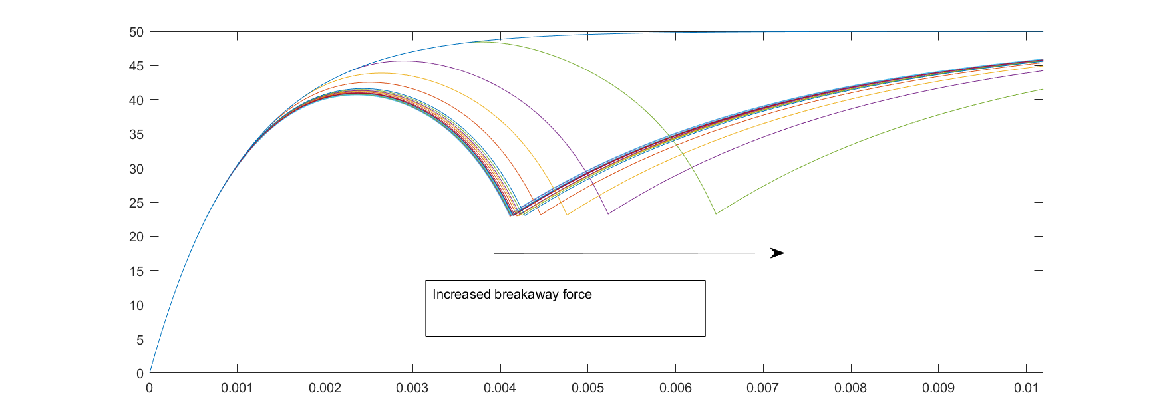

Sweeping through the coulomb friction similarly does not make much sense in isolation as it is simply the ‘residual’ breakaway friction. Therefore, a fixed breakaway friction of 25 N is used instead and the coulomb friction is taken as a proportion of the breakaway friction, starting from 0 % up to 100 % in 10 increments.

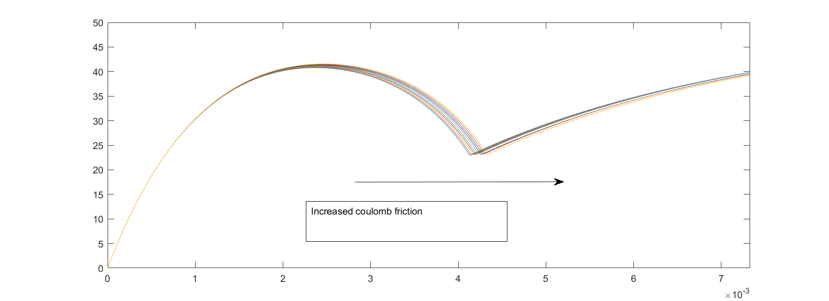

Removing the coulomb friction once more, the viscous friction is looked at next. We see that the effect is very similar to changing the spring stiffness though not identical.

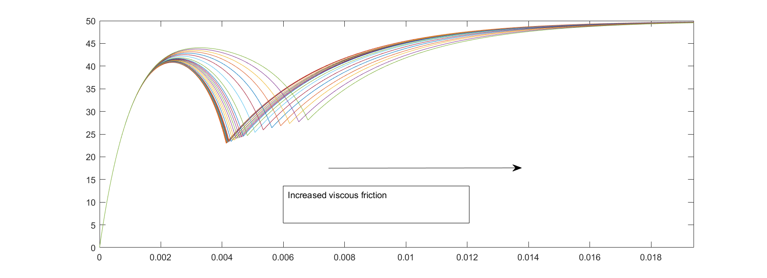

The last element is the latch impact. This was the hardest to model. The collision was simplified greatly to just a damper acting between a range of displacements for the plunger. This was not intended to represent realistically what is occurring during the collision. It is just intended to be a lumped parameter to provide a response range like what was seen in various real traces. The starting and stopping displacement can be altered as well as the damper strength.

Initially, the start and stop distance of 15 mm to 17 mm is constant, and the damping strength is altered. Friction and the spring have been removed. We see that the scaling is quite simplistic.



Next, a coefficient of 500 is kept constant and the latch location is shifted in tandem. We see that it affects how soon Iltch appears after the Ipk. As it is moved further, it takes longer, at which point the plunger is moving faster. This means that there is also less time after the latch to accumulate speed once more. The plot shows if the latch was much further from the buffer to mitigate against the latter affect mentioned. It also highlights a significant limitation to the implementation. As the latch is closer to the starting point, the velocity is lower, this means it takes longer for the plunger to pass through the region representing the latch. Therefore, we see almost independent to the distance, the Iltch timing is the same. However, the further the latch is from the buffer, the more time the plunger has afterwards to accumulate speed, resulting in reduced Ibffrs despite them Ibffrs being delayed.

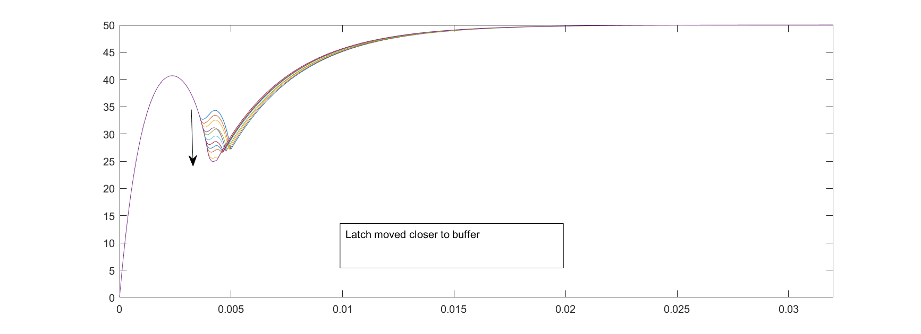

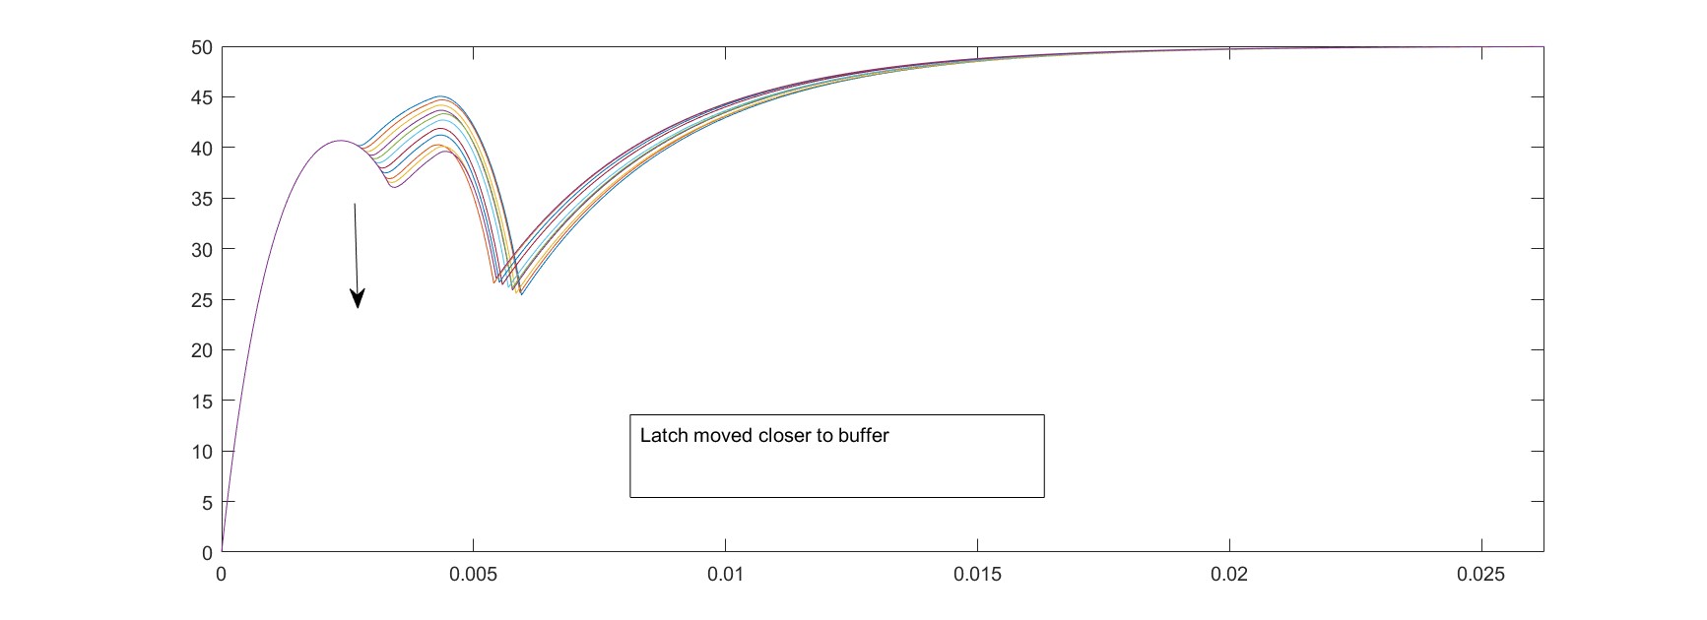

Lastly, the duration of the impact is altered from the initial 2 mm by altering the starting location of the latch. The end location is kept at a constant 17 mm. This is repeated once more with the end location kept at a much further 12 mm. Both show that the asymmetry in the latch ‘bump’ is magnified as the effect is prolonged.

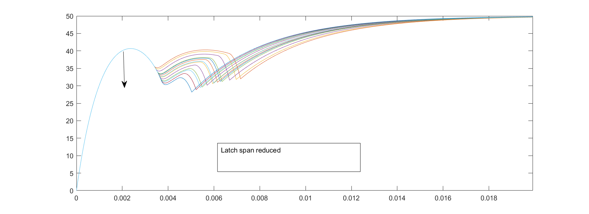

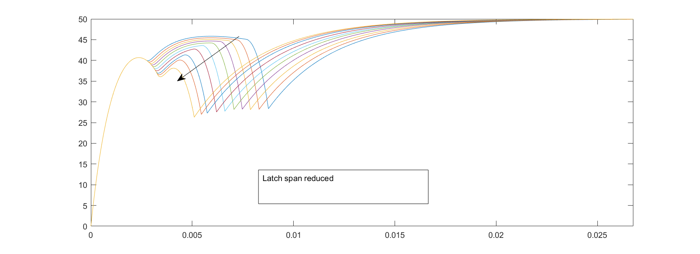

The final plot shows the effect of increasing the span whilst decreasing the coefficient. It is tuned so that the coefficient is 500 * (2/Ltch_Span).



With all the aspects ‘active’, here is a plot adjusting the reluctance and below the resistance





I think there are too many compounding factors in the model to hope to tune them to ‘realistic’ values based on existing traces.

I think what we thought was stiction may instead be either debris or misaligned plunger; something that *reduces* velocity momentarily. Stiction occurs when there is no velocity; that should be almost indistinguishable from a delayed latch opening. The ratio between the Ipk to the Iplt gives an insight as to when sufficient velocity was reached. This either meant stiction delayed the process, or friction or the spring stiffnesses were too high.

Sometimes, there were high frequency rapidly decaying oscillations seen in traces after the buffer. This can be somewhat recreated by have a rebound upon impact with the buffer. It is not clear when this would happen, but some literature indicated that the spring stiffness may be too high.

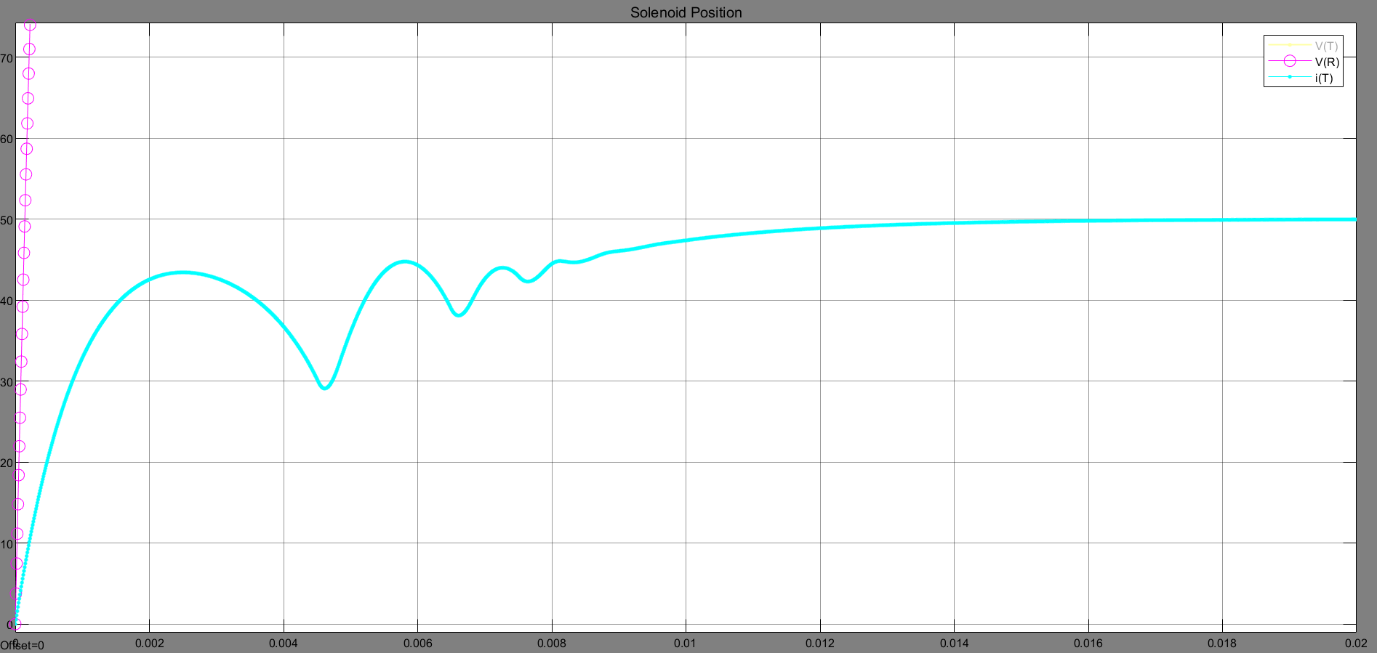

It was thought perhaps increasing temperature led to the downward slop on the plateau. The below plot shows a very simple case where the fixed resistance it scaled linearly after 0.01 second. This does not prove the cause, but also does not rule it out.



Vibration was thought to be a possible source of much of the noise seen in the plateau region. This was modelled very simply using white noise. However, we see that since the buffer is restraining the displacement in one direction, vibration would cause many spikes as opposed to just troughs. However, it may actually be possible that this is measuring the wrong thing; if the sensors are hanging on the circuit-breaker, they may be vibrating relative to the circuit-breaker. It is hard to make any conclusions based on just this. The alternative theory was damaged contacts that caused random amounts of resistance. This is looked at next.

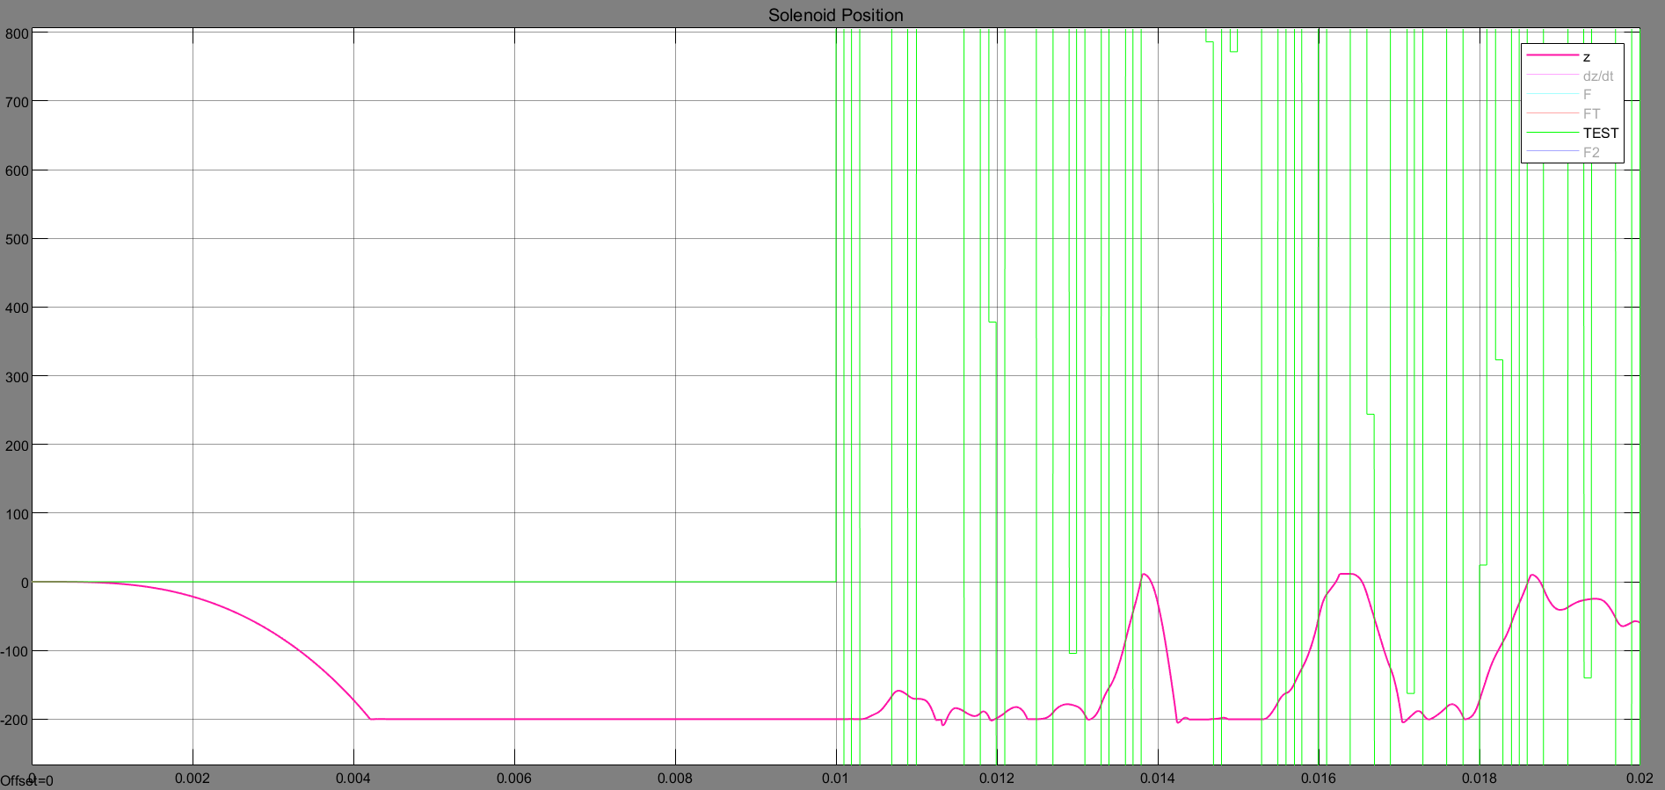

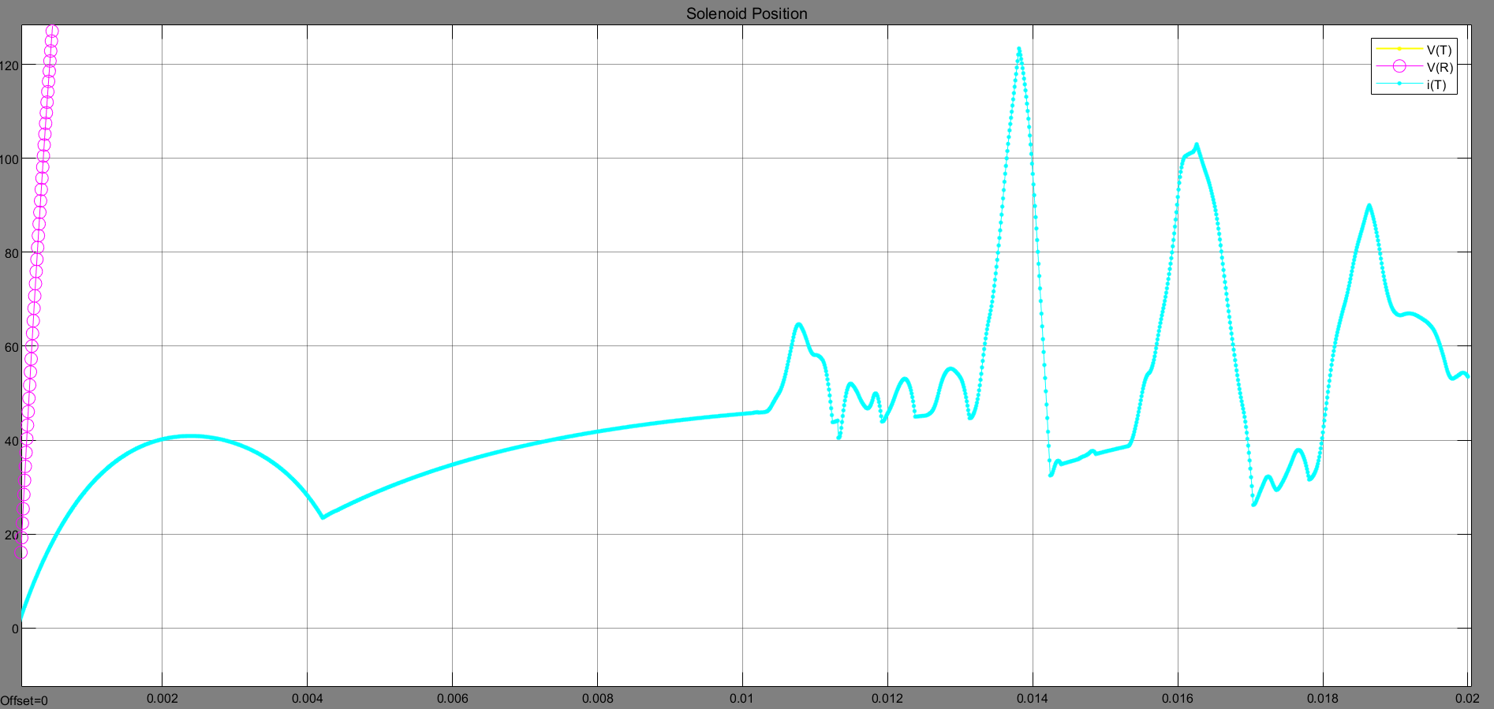

It is possible but again inconclusive. Better inputs are needed to know for sure. It was hard to recreate the large spikes.

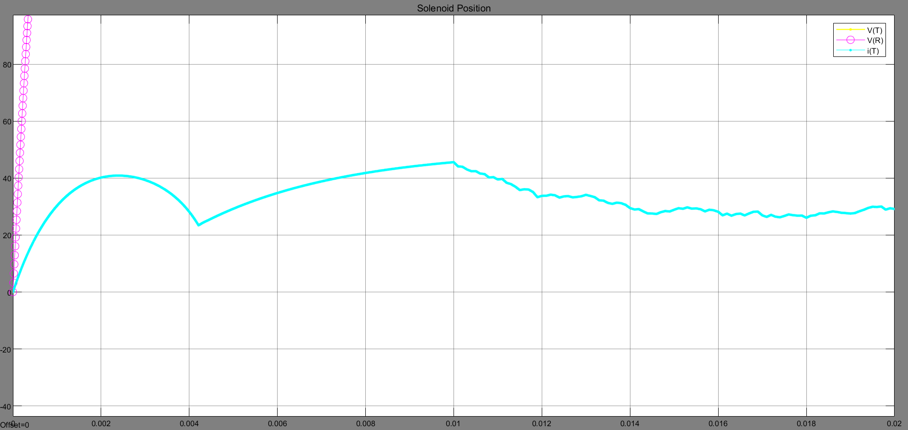

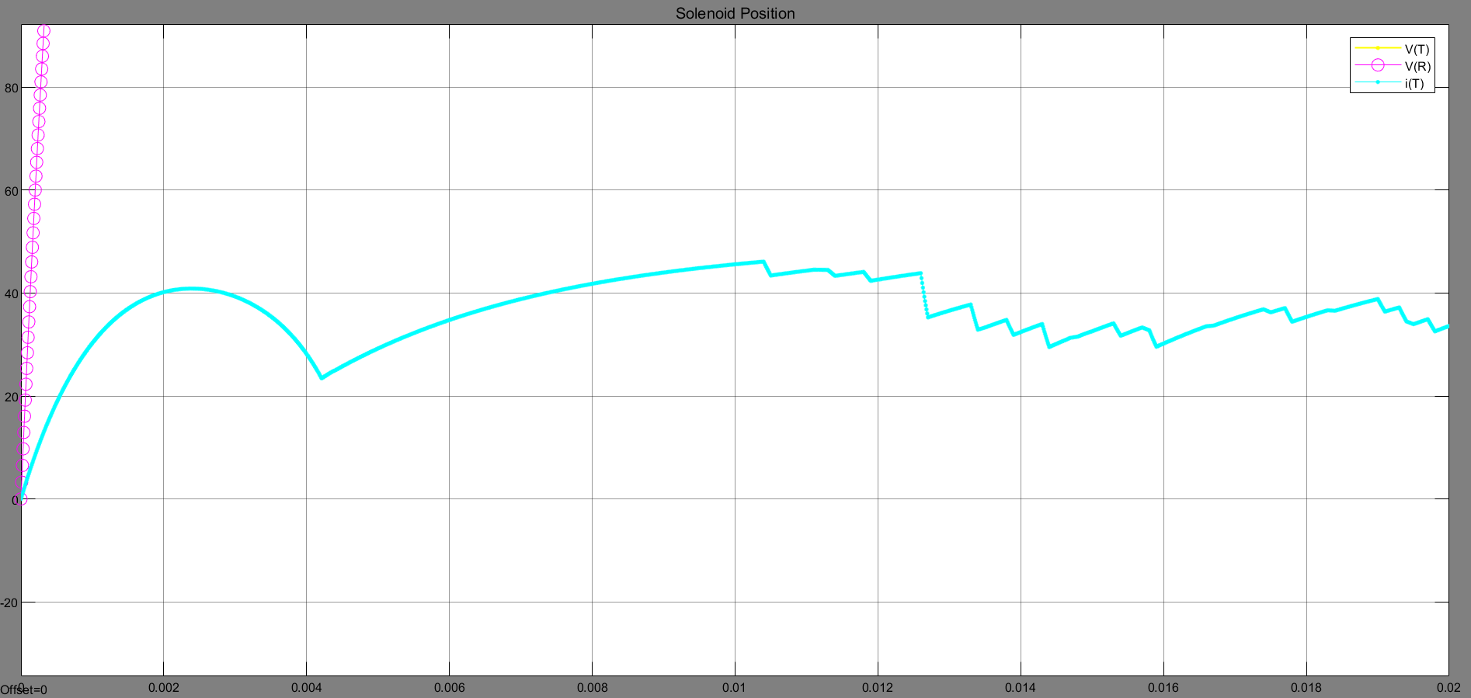

The last aspect looked at is what was guessed as “loose connections” but for that a non-ideal switch must be used, which the model does not have. So, there is not way to test it without investing more time into this.

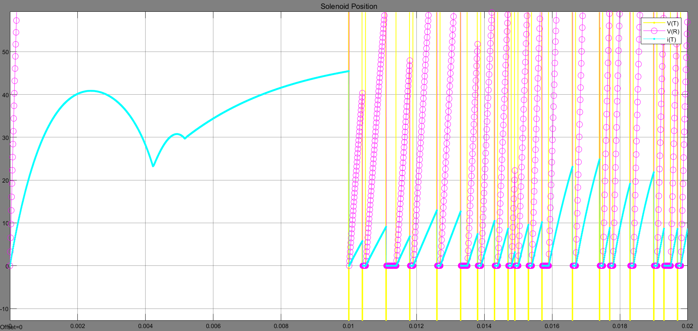

The last, last aspect to look at is voltage drops. A simplified way to look at it is to have internal resistance as a variable. As the internal resistance is increased, so is the voltage drop. This creates the effects shown below, where a range of changed internal resistance in addition to the original fixed constant resistance of the circuit of 7 Ohm. The swept range was from 0 to 7 ohms in 0.7 increments. The voltage was 500 V.



To get a better idea of the relationship, let us look at the ratios. At 0.7 Ohm addition which is either 0.7/7 (10%) or 0.7 / 7.7 (9.1%) depending how you see it. We have a Vdrop of about 44.4V (8.88%). At 1.4 Ohm 20% or 15.6% we have a Vdrop of about 81.9V (16.38%). At 2.8 Ohm 40% or 28.6% we have Vdrop of about 141.6 V (28.32%). At 5.6 Ohm 80% or 44.4% we have Vdrop of about 221.5 V 44.3 %.

It looks like it is approximately proportional. Therefore, the ratio of internal resistance to overall resistance is closely correlated to the ratio of the initial voltage and the voltage drop. Just to make sure, the next plot reduces the circuit resistance at the same rate the internal resistance is being raised, i.e. overall resistance is kept constant. For the case of 0.5 Ohm internal resistance and 6.5 Ohm circuit resistance (i.e. total 7 Ohm): taking the initial voltage (500 V) and the final current (71.3 A) you get a Resistance of 7 Ohm. Then taking the Vmin (463.7) from the same current gives 6.52 Ohm, leaving approximately 0.5 Ohm which was the correct internal resistance. This looks perfect but it is important to note that the plateau has been prolonged much longer than seen in real traces to allow for it to ‘settle’. This does suggest that the rate of voltage drop during sustained current can be used to track increased internal resistance (maybe).



REL of 5.3420 AND LOWER BLOWS UP!!!

Another issue is that many of the real traces saw the voltage continue to drop over time during the current’s plateau. This could be due to increased temperatures or can be an aging battery’s reduced capacity leading to voltage collapse at modest current draws. This is too complicated to model for this project. However, where possible, measuring the ‘taper’ of the plateau could be very useful indicator for the state of the battery health.

The main purpose of this model is to explore the system, and then to recreate regular waveforms. The next portion will look at recreating real traces.

**Parameter guessing**

These are just rough ball-park values based on *anything*. There are two main sources, “Distributions of Performance of Trip Coil Data” report that I made for NPG, and the paper: “Diagnosing Medium Voltage GIS Circuit Breaker by Observing Trip Coil Current with Simulation and Actual Tests”.



Because I need to have more detailed measurement, I cannot use above figure and instead using below figure. It is close enough that it is deemed representative.

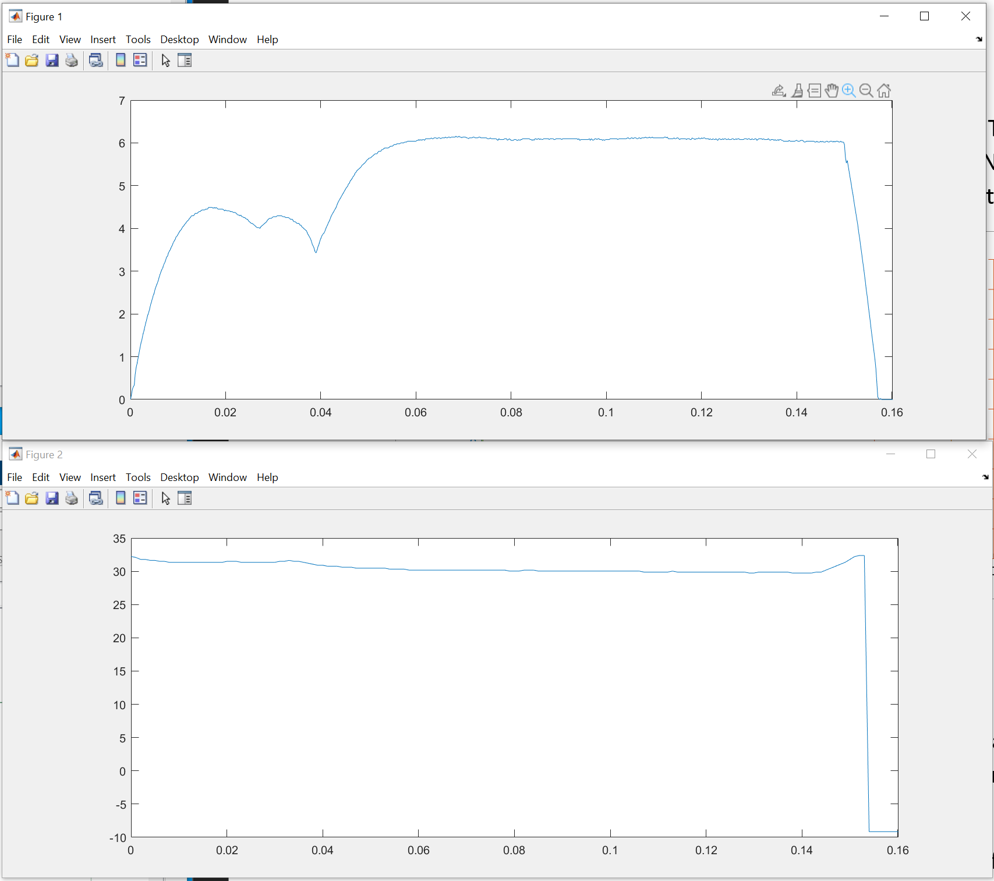

**Electrical side:**

Voltage

Most of the real records have both current and voltage traces. However, the voltage levels are not constant as they were in the model, even when the current draw is constant. This is a function of their rising temperatures or battery degradation.

Looking at the A7T, there was an average initial voltage of **33.5 V**.

Resistance

Looking at the A7T, and V = IR. Instead of using average values, specific trace is chosen. The above figure shows two traces that were previous chosen for being somewhat ‘typical’. It has initial voltage of 33.5 V and the lower Iplt is 6.1 A (though it wavers) giving an approximate resistance of 5.5 Ohms. The Voltage later drops to 30.2 V (though it keeps dropping), indicating initial **internal resistance of approximately 0.55 Ohms and residual resistance of 4.95 Ohms**.

By the end, it drops to 29.74 V and a current of 6.04 A. This would have made a guess of 5.55 Ohms total, 0.63 Ohms internal and 4.92 Ohm residual. Some stuff can be done here regarding the slopes etc, but for now will not be taken any further. For example, these numbers indicate the residual resistance remained about the same (i.e. coil not really heating up), but the internal resistance rose. If instead the residual rose significantly, we could say it is perhaps the coil.

Winding turns

There is no real way to know this as far as I know. Based on the other paper, it had 1800 turns. But that also had a higher Voltage (125 V) and coil resistance (31.2 Ohms). It is really hard to relate these, but a few logical steps (leaps of faith) are made as following:

Assume the number of winding turns is directly proportional to the overall resistance of the coil.

Assume the coil resistance is approximately the entirety of the residual resistance.

If we have a resistance of 5.5 Ohm, that is 17.6 % of the coil resistance in paper, which would be ~317 turns. Since we’re making stuff up, we should probably assume our fixed resistance due to the rest of the circuitry is higher than in their testcase, and so we can just round down to ~300 turns.

Solenoid dimensions

I am not entirely sure this is needed but I cannot think of a reason why it is not included in the calculations. Also, if not taking the same number of windings, it is a bit strange to take the same dimensions from the paper. Nevertheless, assuming the solenoid is cylindrical, and that the area is the area left open for the plunger, their figure would indicate an area of approximately 3.141 cm2 and a length of 19.9 m giving a ratio of 0.001577 which is an issue because it affects the results way too strongly. **For now, it is being ignored!**

**Magnetic side:**

Inductance

This is also very difficult to measure. τ is taken as the ratio of L/R, and a very useful heuristic is that 5τ is approximately the time taken for the current to plateau. If we say 6 A is the plateau and we look at time taken to reach 4 A instead (66.7 %), it would be 1.1 τ. This is obviously imprecise. Taking a higher current level risks the motion of the plunger interfering with the results. In this example, 4 A was reached at 0.0108 s giving a τ of 0.00982, giving an **Inductance (L) of approximately 0.0486 H**. Remember, we must use residual resistance (4.95 Ohms).

We could also look at the calculated L after buffer. At 0.039 s the current is 3.431 A and levels out to 6.14 A. So initial is 55.9% at adjusted time of 0 s and ~100 % at time of 0.0304 s. That is ~0.819 τ at start. It reached 6 A after 0.0184 s (~97.8 % of max current) which about 3.8 τ. Therefore, it went 2.98 τ in this time. This gives a τ of approximately 0.00617, giving a Reluctance (L) of approximately 0.0305 H, significantly lower (~66%). This could indicate the initial measurement was taken at too high a current level where plunger had already begun its motion. As mentioned before, the plunger closing the air gap decreases the reluctance (0.0181 H) and increases the rate of current change. The residual reluctance will be from the minimum air gap, the gaps between plunger and yoke, and losses (the last assumed negligible). It is worth noting that in the paper’s picture, the plunger is on a shaft that connected to the yoke, this is not assumed in the model and can affect the results.

Initial air gap

This is based from the paper, so the **initial air gap is taken as 20 mm**. It is hard to know how applicable this is more broadly.

Minimum air gap

The paper does not specify. If there is no air gap, the plunger can stick to the magnetised core. The gap is usually not ‘air’ but a non-magnetic shim etc. It is assumed that the **minimum air gap is 1 mm**.

Cross-sectional Area

This is based from the paper, so the **cross-sectional area is taken as 1.7671 cm2.**

Relative Permeability

The paper does not specify. Often people skip this as it is argued as negligible as compared to the air gap. For example, the Reluctance Force Actuator in Matlab also skips this. Values vary wildly depending on materials. In general, the range is between 1 and 4000. Something like carbon steel is at 100 and electrical steel at 4000. We can assume something at least mildly appropriate was used as a material and therefore that the **relative permeability is irrelevant**.

**Mechanical side:**

Mass

Frustratingly, the paper says it was measured, but it does not state the actual value. Steel is around 7.75 and 8.05 g/cm3. Based on dimensions they gave it has a volume of about 11.138 cm3 which is about 86 – 89.6 g. This is assuming I understood the figure correctly! Therefore, a **mass of 88 g** is taken.

Spring Tension

**The paper does not specify the value.** It can *maybe* be inferred the value is 0.6 kg based on their figure at max distance (i.e. 20 mm) meaning giving ~0.3 N/mm. But it looks like there is also its own weight to subtract, giving closer to **~0.25 N/mm.**

Spring pre-tension

**The paper does not specify the value.** It can *maybe* be inferred that it is **negligible based on their figure**.

Static Friction (breakaway force)

**The paper does not specify the value.**

Viscous Friction (Coulomb Force)

**The paper does not specify the value.**

Viscous Coefficient

**The paper does not specify the value.**

Latch Start

The paper does not explicitly say, but from the graphs the **Latch start can be inferred as** **10 mm from initial starting point**

Latch End

The paper does not explicitly say, but from the graphs it looks like ends at the buffer, therefore at **20 mm from initial starting point**

Latch Damping Coefficient

The paper does not specify but their figures indicate ~9 N force applied during the Latch. Please note this is force and not damping coefficient, I’m not sure how to relate the two.

Buffer Location

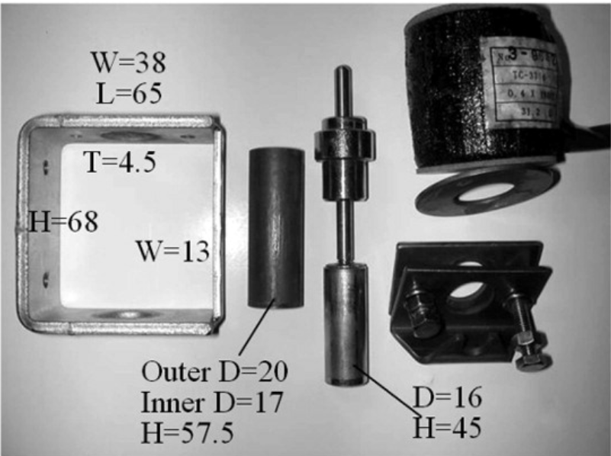



I am getting stuck trying to have reasonable parameters and have it result in reasonable trace. I am just going to try and build on what is here for now and forget the rest.





We have an issue in that the plunger may be moving from very early on, this can affect the estimation of the inductance prior Ipk. We can perhaps still use the post-buffer value. There is a chance that this model is a push actuator rather than a pull actuator.

Let us look at replicating a paper:

<https://ieeexplore.ieee.org/stamp/stamp.jsp?tp=&arnumber=7381746>

It has 2 CBs.

A

V 125

R = 31.2

NW = 1800

Inner Dia = 8 mm

Outer Dia = 32.5 mm

Z-ltch = 10 mm

Z-ltch = 16 mm (+10mm)

Mass = 1040g

I couldn’t get the model to match the traces I was seeing in real life. The balance in trying to get the right reluctance before and after the plunger had moved, whilst also maintaining the right velocity of the plunger is too demanding.

My next plan is to see if I can recreate the trace that they have in their paper with my model. If I can, I can say that is my proof-of-concept, then I can explain why it is too challenging to try and get the params to all fit.

I will then end it there by writing it up. The step after that will be using maths instead.